Advertising Proposal – Marrakech Menara International Airport

Boarding – Elevator & Wall Wrap
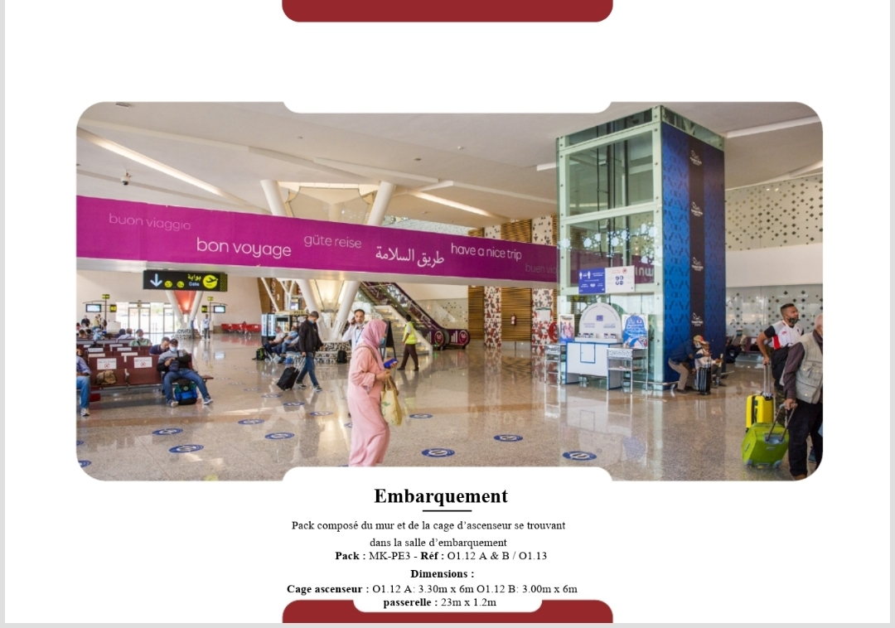
Located at the entrance of the main boarding lounge, directly above and beside the glass elevator shaft. Highly visible from all waiting areas and traffic toward gates.
Pack: MK-PE3
Reference: 01.12 A & B / 01.13
Location: Boarding Lounge
Dimensions:
- Elevator Cage A: 3.30m x 6.00m
- Elevator Cage B: 3.00m x 6.00m

Boarding – Escalator & Opposite Wall
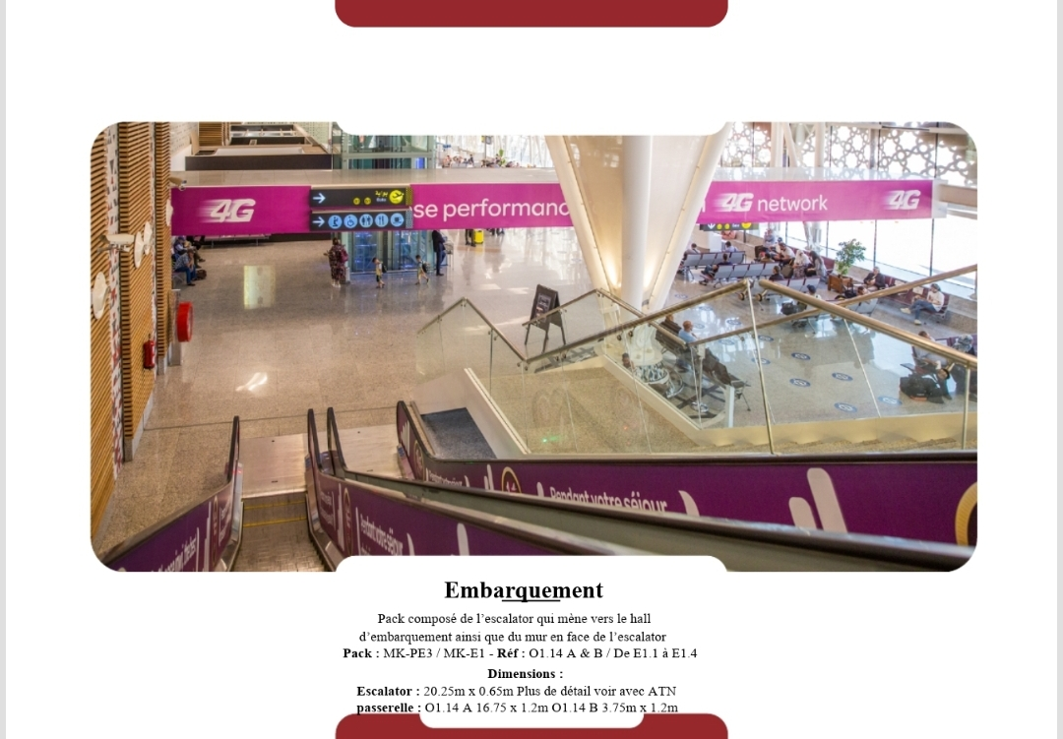
Positioned on both the escalator rising to the boarding level and the facing wall. Ideal exposure for passengers approaching the departure gates.
Pack: MK-PE3 / MK-E1
Reference: 01.14 A & B / E1.1 to E1.4
Dimensions:
- Escalator: 20.25m x 0.65m
- Walkway A: 16.75m x 1.2m
- Walkway B: 3.75m x 1.2m

Boarding – Escalator Wrap
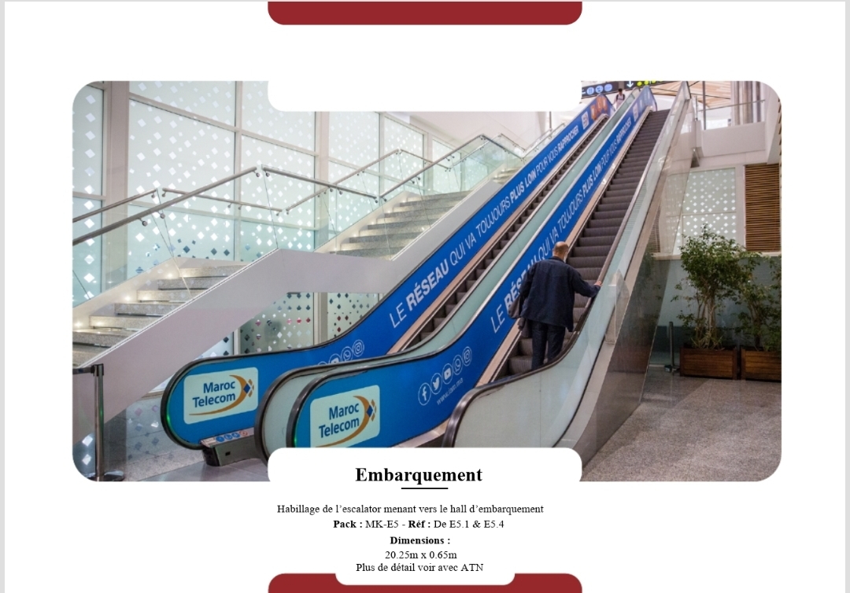
Key location within passenger flow zone.
Pack: MK-E5
Reference: E5.1 & E5.4
Dimensions: 20.25m x 0.65m

Boarding – Wall Panel
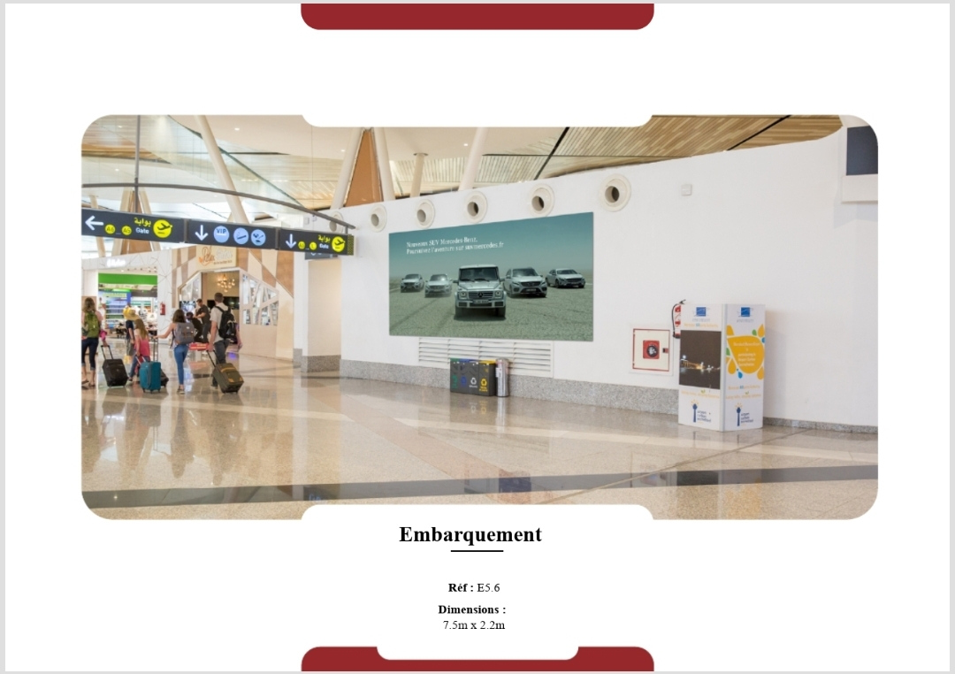
Key location within passenger flow zone.
Reference: E5.6
Dimensions: 7.5m x 2.2m

Jet Bridges – External Panels
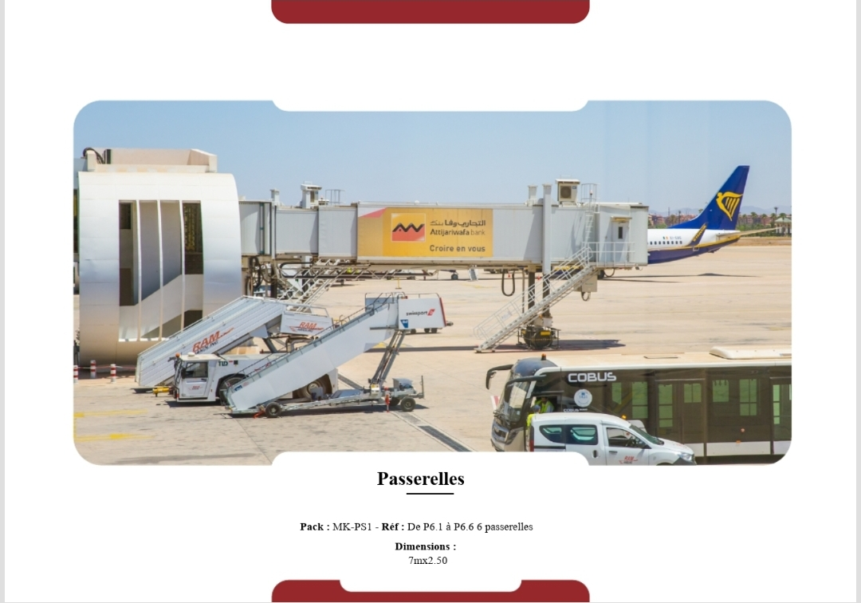
Exterior jet bridges viewed by all passengers boarding through these tunnels. Direct plane-side branding.
Pack: MK-PS1
Reference: P6.1 to P6.6
Dimensions: 7m x 2.5m per jet bridge

Deboarding – Travelator Corridor
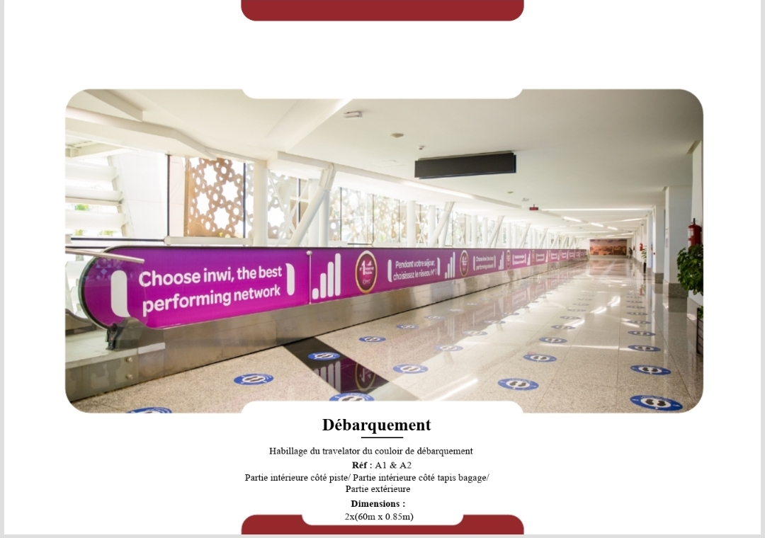
Long panel along the arrival travelator tunnel, welcoming passengers disembarking from planes toward immigration.
Reference: A1 & A2
Dimensions: 2 x (60m x 0.85m)

Deboarding – Wall Panels (Set 1)
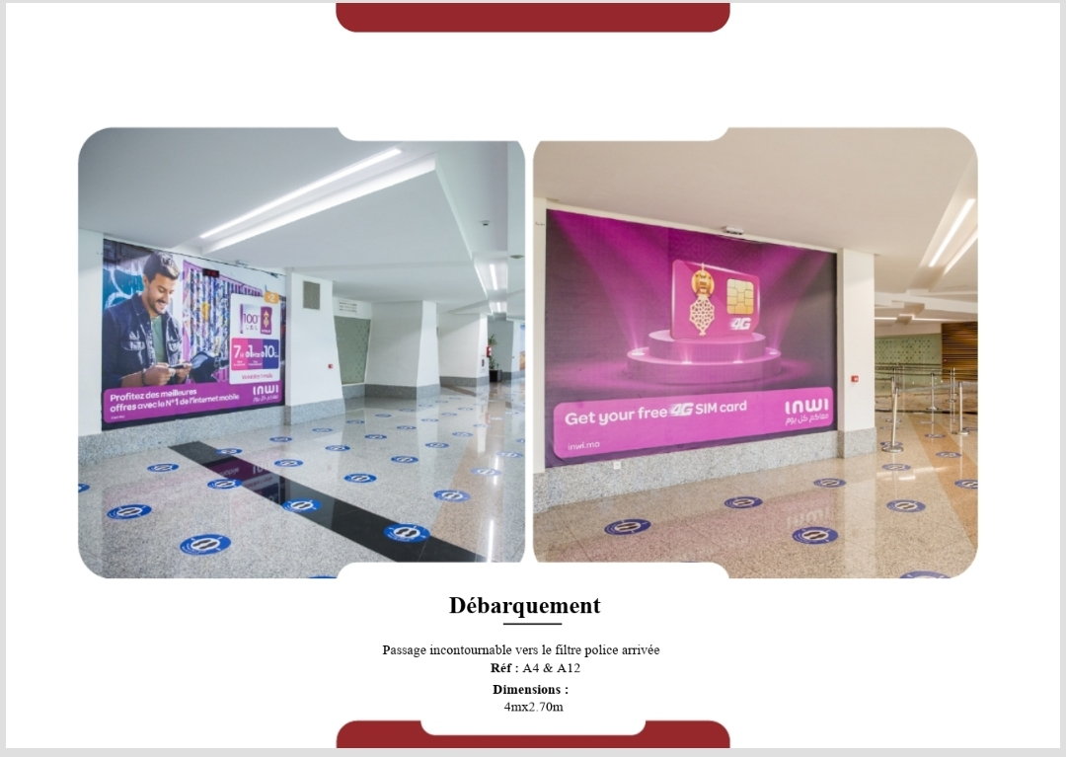
At the key junction leading to immigration police filter, ensuring all arriving passengers pass directly by.
Reference: A4 & A12
Dimensions: 4m x 2.7m each

Deboarding – Wall Panels (Set 2)
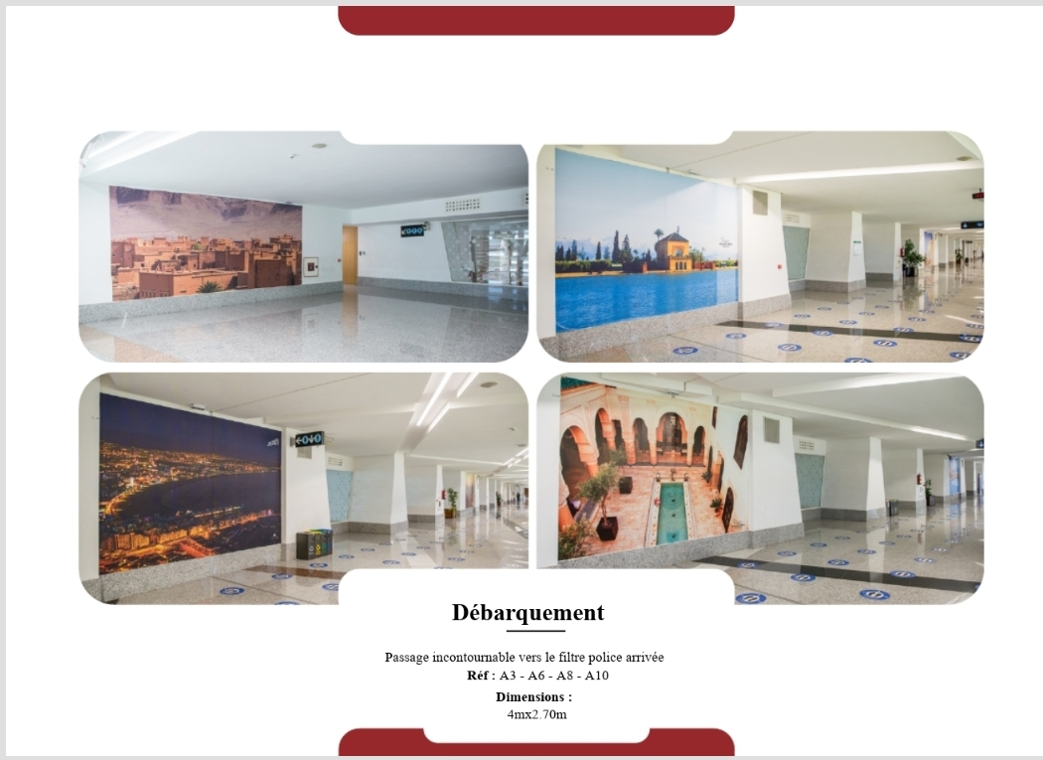
In the corridor funneling passengers to police and baggage zones, with uninterrupted wall space ideal for storytelling.
Reference: A3, A6, A8, A10
Dimensions: 4m x 2.7m each

Deboarding – Wall Panels (Set 3)
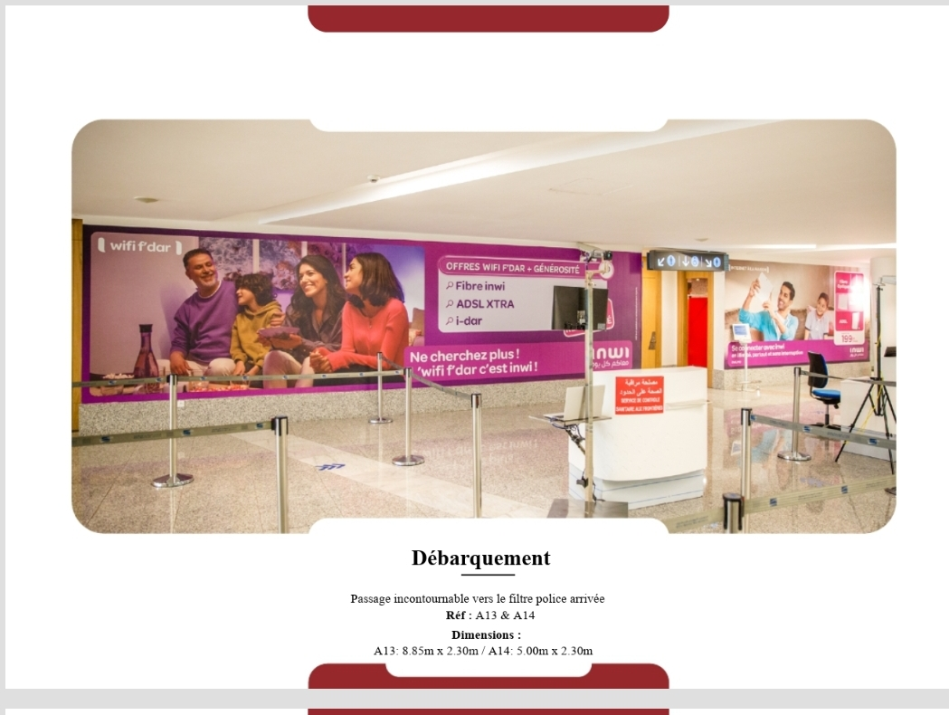
In the corridor funneling passengers to police and baggage zones, with uninterrupted wall space ideal for storytelling.
Reference: A13 & A14
Dimensions:
- A13: 8.85m x 2.30m
- A14: 5.00m x 2.30m

Deboarding – Escalator Wraps (Set 1)
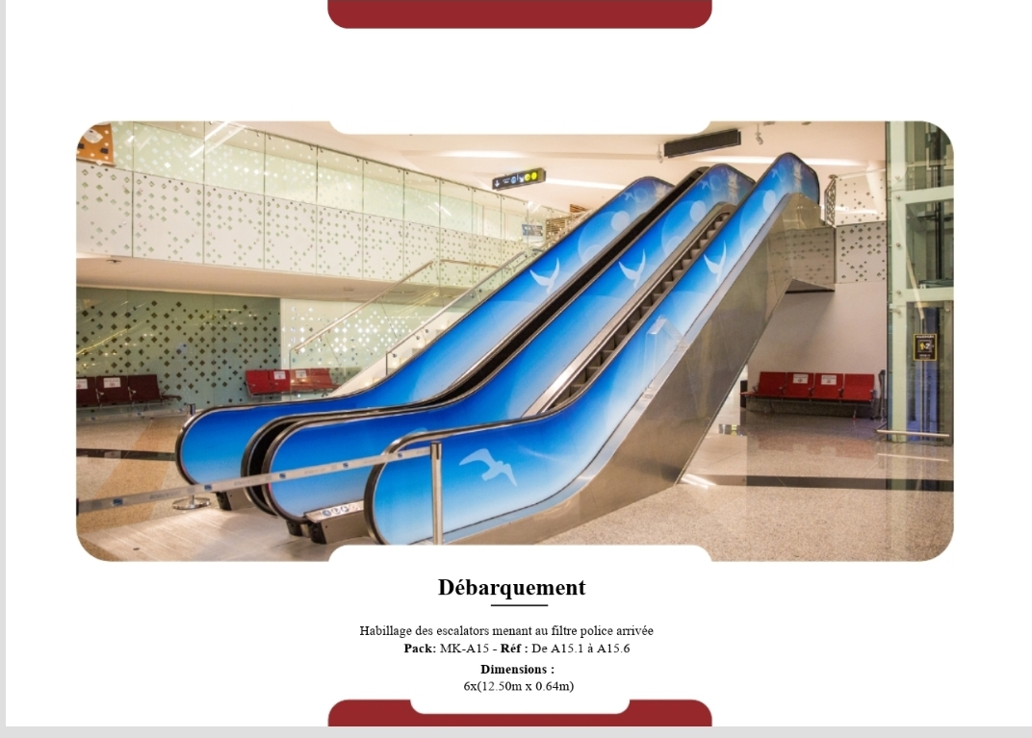
Wraps the entire escalator path where passengers descend or ascend between levels, facing directly toward foot traffic.
Pack: MK-A15
Reference: A15.1 to A15.6
Dimensions: 6 x (12.5m x 0.64m)

Deboarding – Escalator Wraps (Set 2)
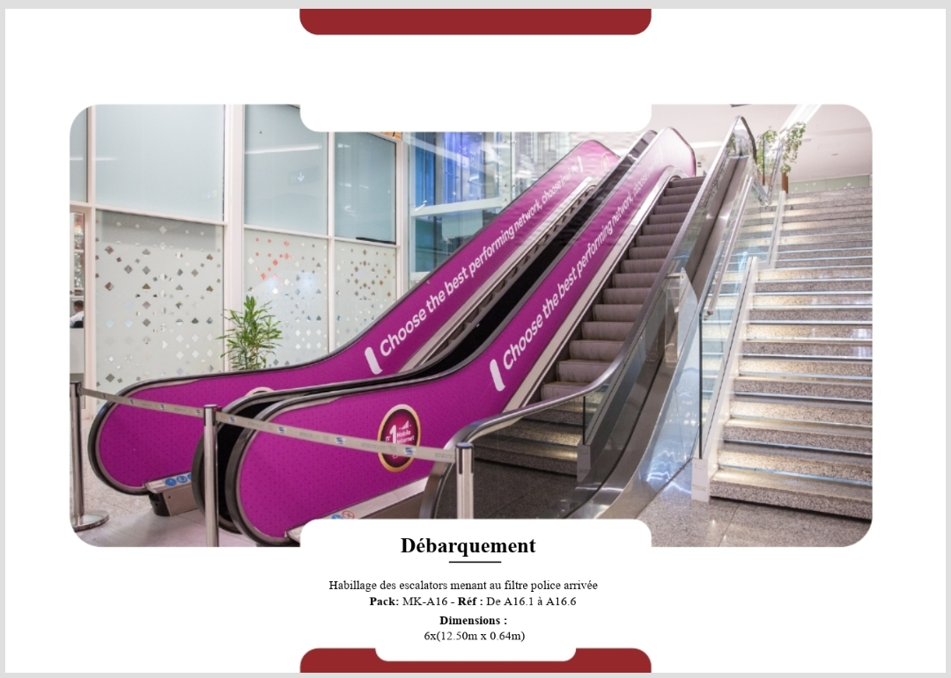
Wraps the entire escalator path where passengers descend or ascend between levels, facing directly toward foot traffic.
Pack: MK-A16
Reference: A16.1 to A16.6
Dimensions: 6 x (12.5m x 0.64m)

Passport Control – Main Entry
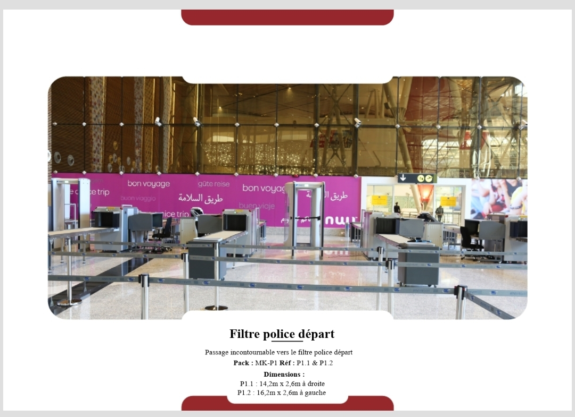
On the main security walls directly behind passport control scanning systems, ensuring maximum exposure during wait times.
Pack: MK-P1
Reference: P1.1 & P1.2
Dimensions:
- Right: 14.2m x 2.6m
- Left: 16.2m x 2.6m

Passport Control – Queue Panels (Set 1)
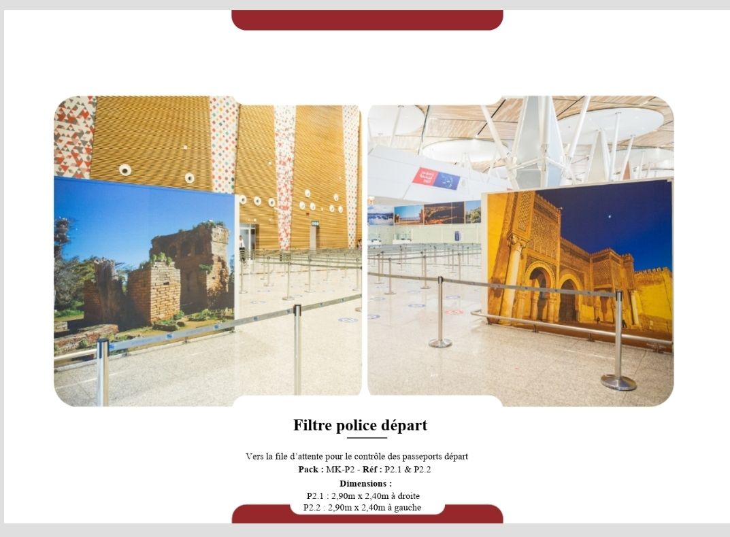
Panels flank the line divider paths for outbound passport checks, seen by every departing traveler.
Pack: MK-P2
Reference: P2.1 & P2.2
Dimensions: 2.90m x 2.40m each

Passport Control – Queue Panels (Set 2)
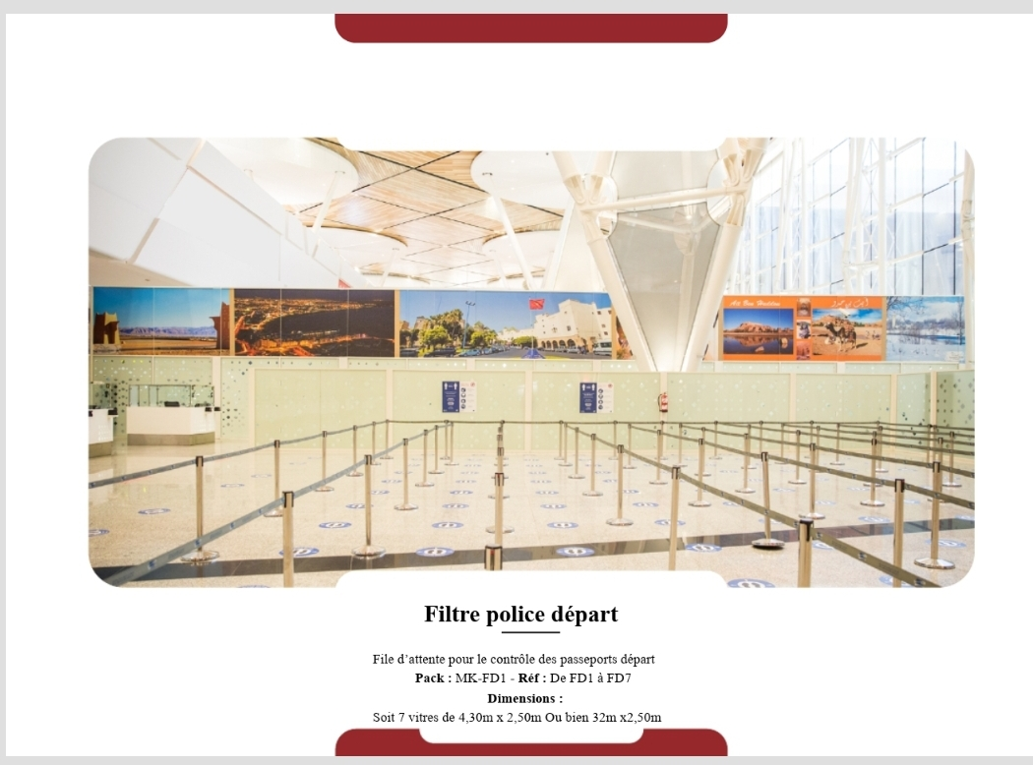
Panels flank the line divider paths for outbound passport checks, seen by every departing traveler.
Pack: MK-FD1
Reference: FD1 to FD7
Dimensions: 7 panels of 4.3m x 2.5m or one 32m x 2.5m

Passport Control – Booth Wall Panels
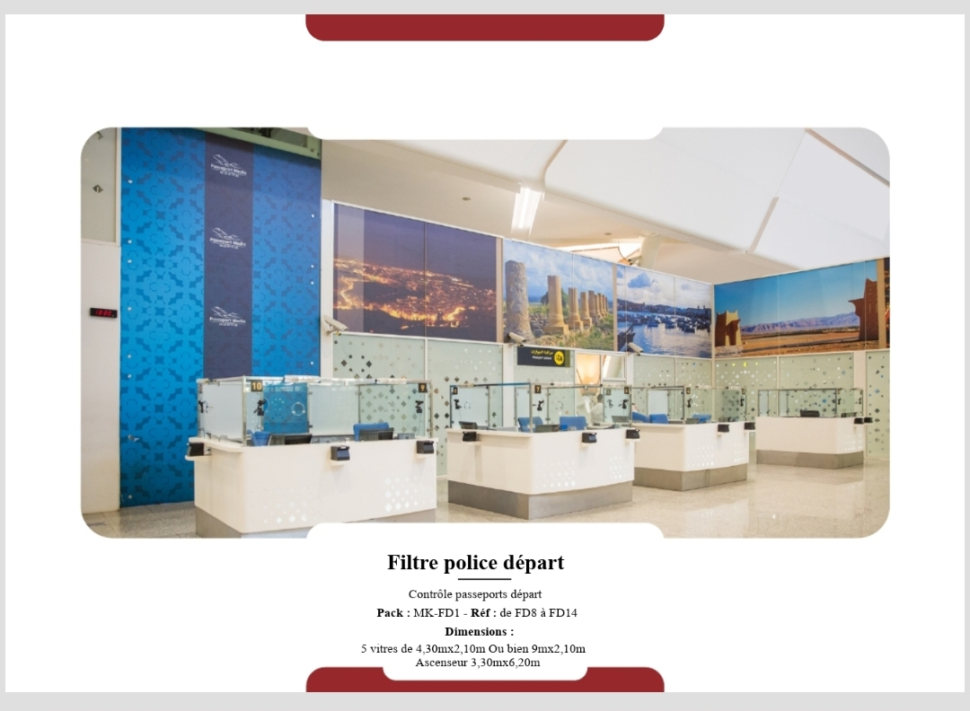
At the exit point of police stamp booths, visible throughout queue and check areas.
Pack: MK-FD1
Reference: FD8 to FD14
Dimensions:
- 5 panels of 4.3m x 2.1m or one 9m x 2.1m
- Elevator wrap: 3.3m x 6.2m

Exit Zone – Main Panels
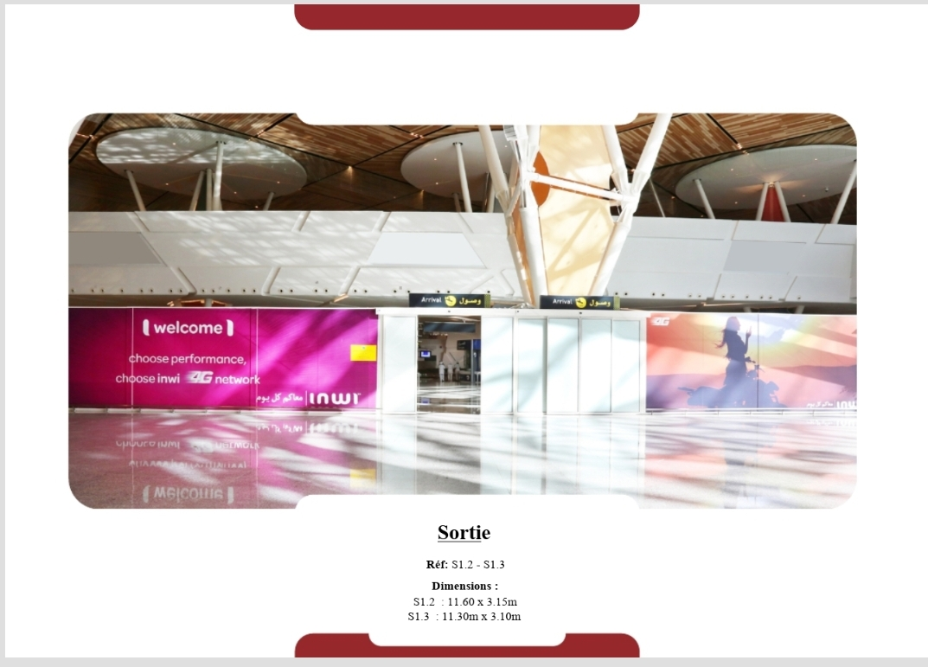
Installed at the exit tunnel just before terminal departure. High visibility during last moments in terminal.
Reference: S1.2 & S1.3
Dimensions:
- S1.2: 11.60m x 3.15m
- S1.3: 11.30m x 3.10m

Public Hall – Glass Panels
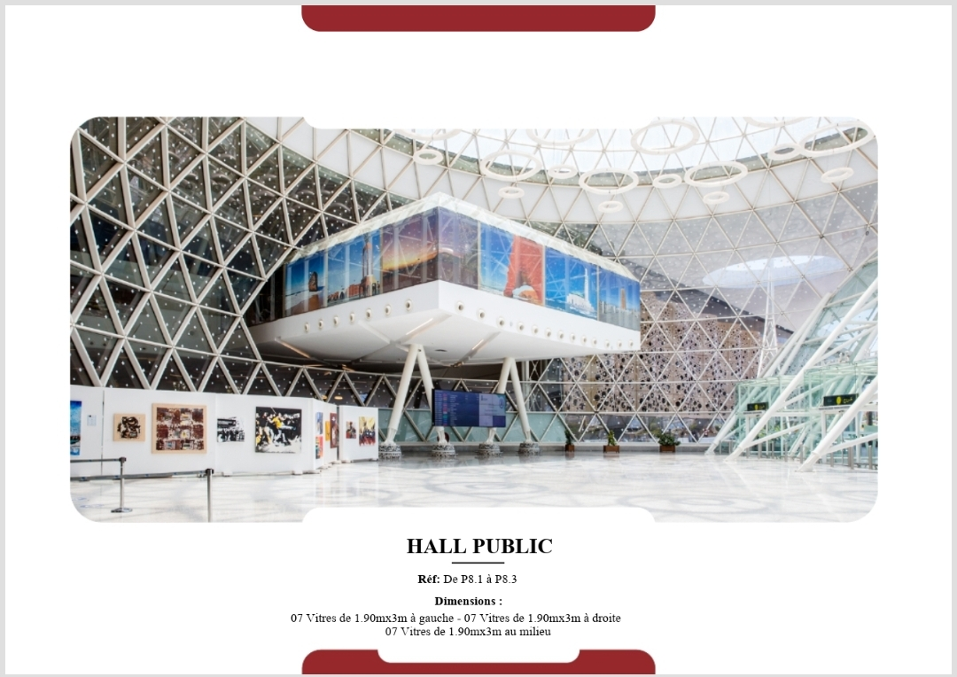
Central atrium of the terminal before security checks, visible to all public guests and greeters.
Reference: P8.1 to P8.3
Dimensions:
- 7 panels left: 1.90m x 3m
- 7 panels right: 1.90m x 3m
- 7 panels middle: 1.90m x 3m

Luggage – Opposite Wall Panels
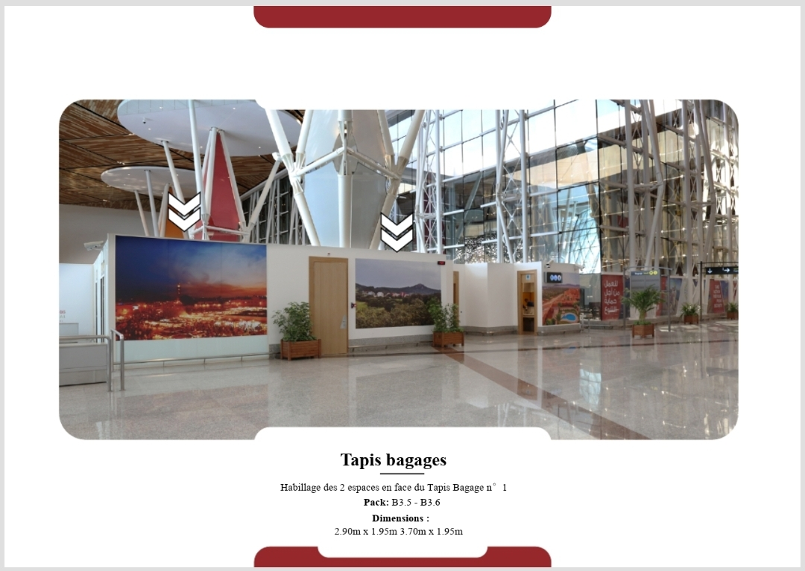
Key location within passenger flow zone.
Pack: B3.5 - B3.6
Dimensions:
- 2.90m x 1.95m
- 3.70m x 1.95m

Interior Dome Wall Wrap
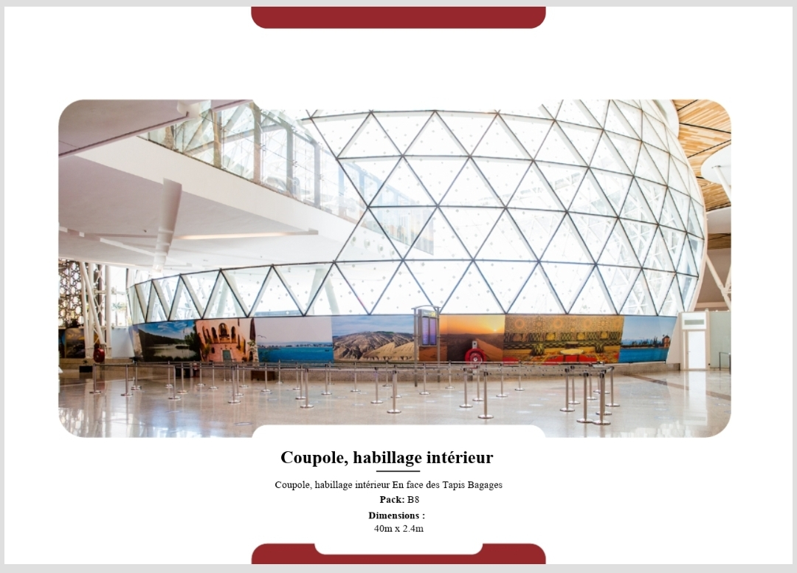
Centrally located opposite luggage belts inside the architectural dome, with panoramic visibility.
Pack: B8
Location: Facing luggage belts
Dimensions: 40m x 2.4m

