Advertising Proposal – Marrakech Menara International Airport

## Boarding – Elevator & Wall Wrap

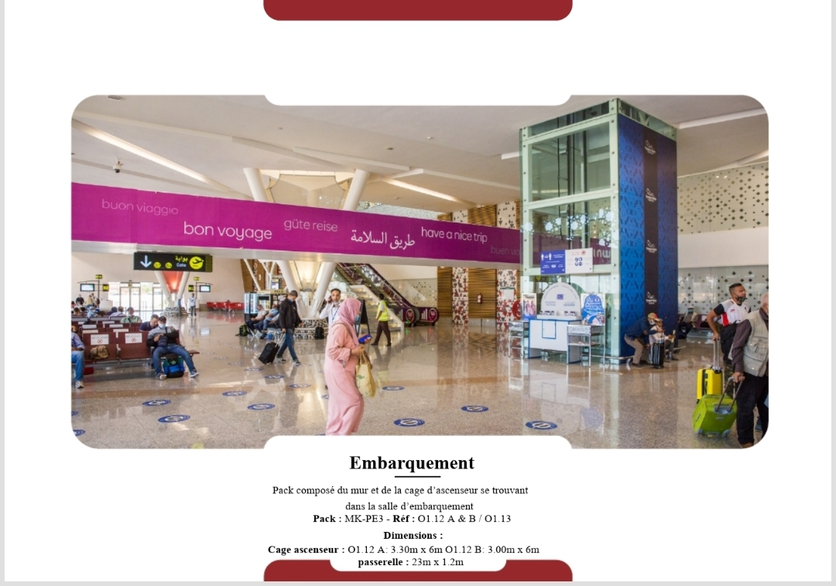

Located at the entrance of the main boarding lounge, directly above and beside the glass elevator shaft. Highly visible from all waiting areas and traffic toward gates.  
  
Pack: MK-PE3  
Reference: 01.12 A & B / 01.13  
Location: Boarding Lounge  
Dimensions:  
- Elevator Cage A: 3.30m x 6.00m  
- Elevator Cage B: 3.00m x 6.00m

## Boarding – Escalator & Opposite Wall

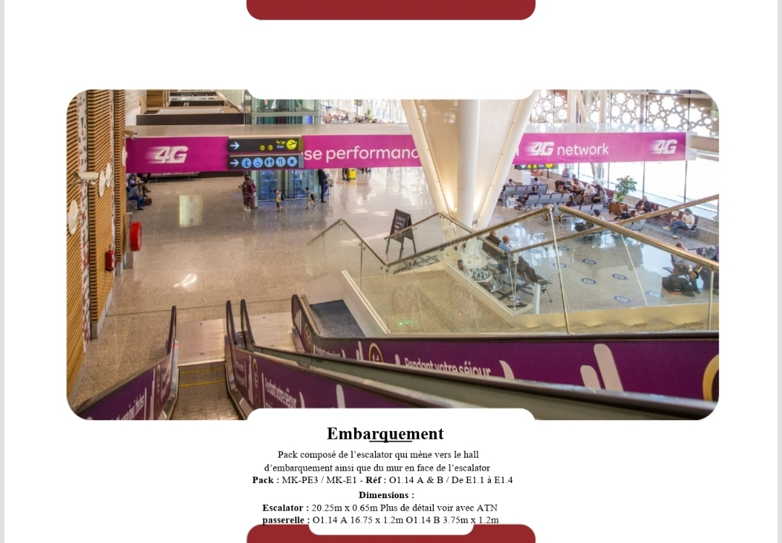

Positioned on both the escalator rising to the boarding level and the facing wall. Ideal exposure for passengers approaching the departure gates.  
  
Pack: MK-PE3 / MK-E1  
Reference: 01.14 A & B / E1.1 to E1.4  
Dimensions:  
- Escalator: 20.25m x 0.65m  
- Walkway A: 16.75m x 1.2m  
- Walkway B: 3.75m x 1.2m

## Boarding – Escalator Wrap

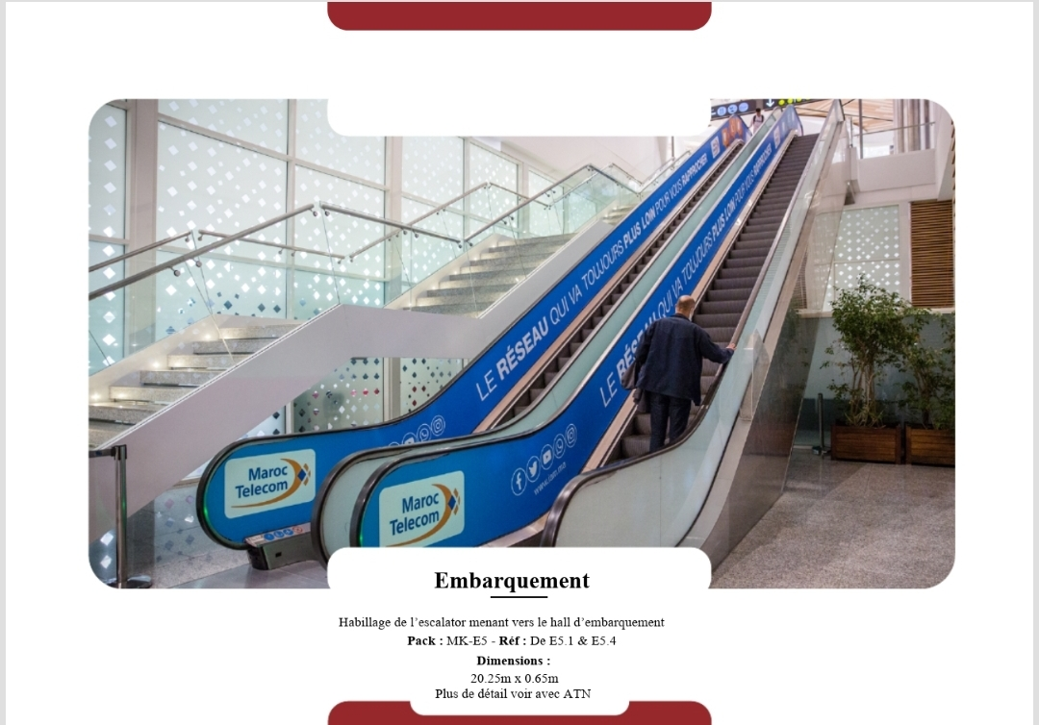

Key location within passenger flow zone.  
  
Pack: MK-E5  
Reference: E5.1 & E5.4  
Dimensions: 20.25m x 0.65m

## Boarding – Wall Panel

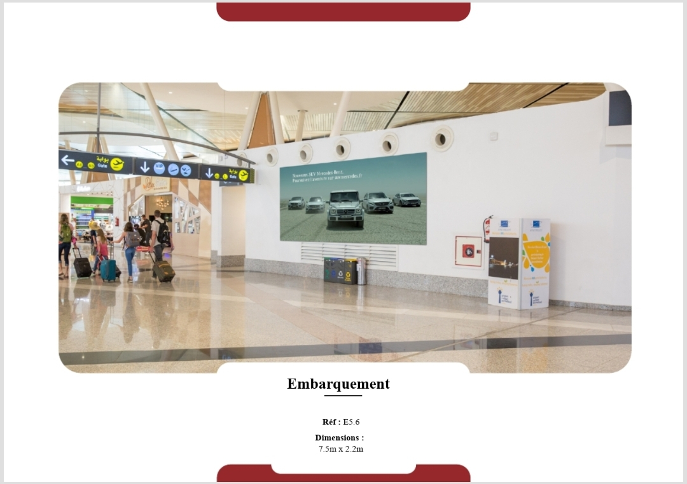

Key location within passenger flow zone.  
  
Reference: E5.6  
Dimensions: 7.5m x 2.2m

## Jet Bridges – External Panels

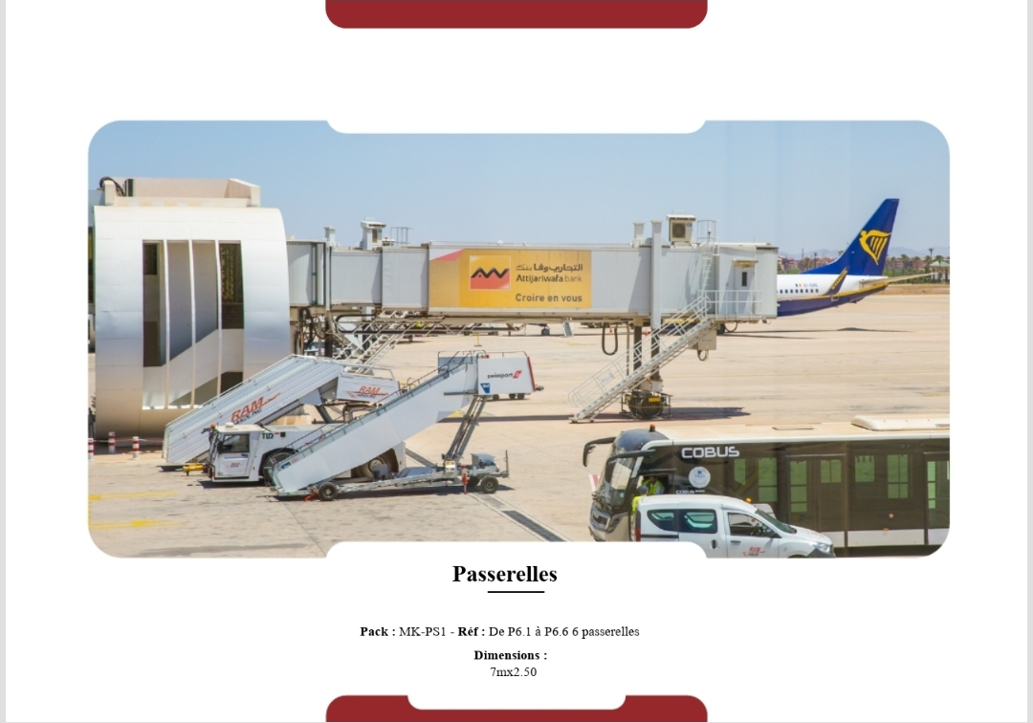

Exterior jet bridges viewed by all passengers boarding through these tunnels. Direct plane-side branding.  
  
Pack: MK-PS1  
Reference: P6.1 to P6.6  
Dimensions: 7m x 2.5m per jet bridge

## Deboarding – Travelator Corridor

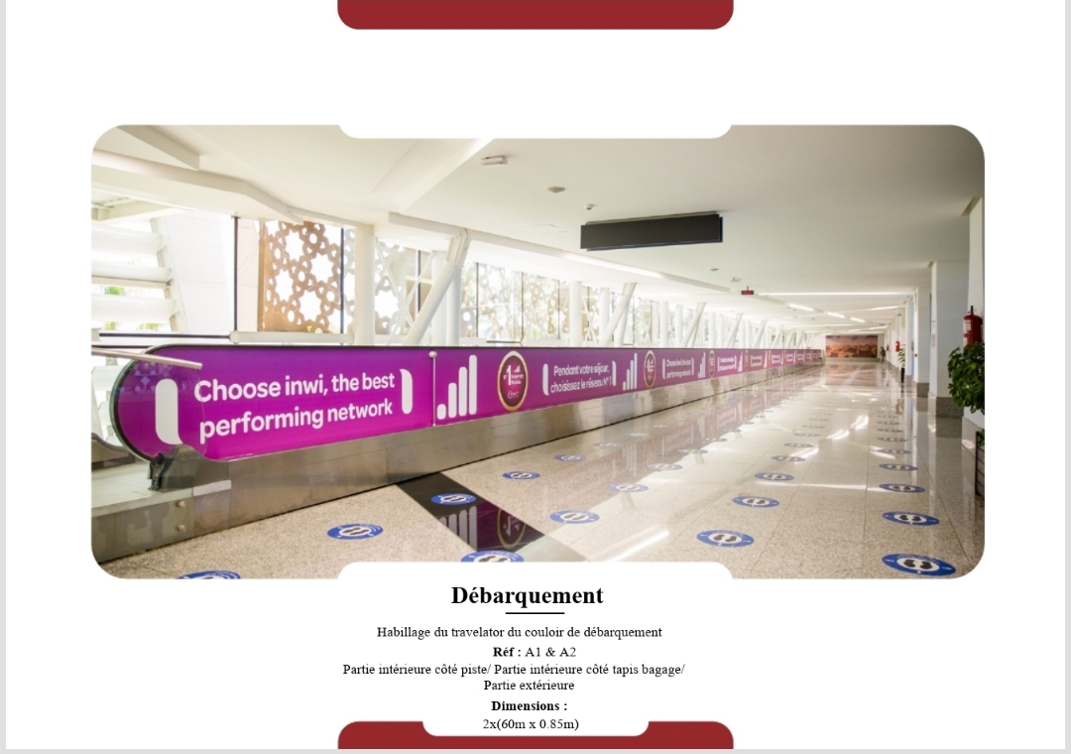

Long panel along the arrival travelator tunnel, welcoming passengers disembarking from planes toward immigration.  
  
Reference: A1 & A2  
Dimensions: 2 x (60m x 0.85m)

## Deboarding – Wall Panels (Set 1)

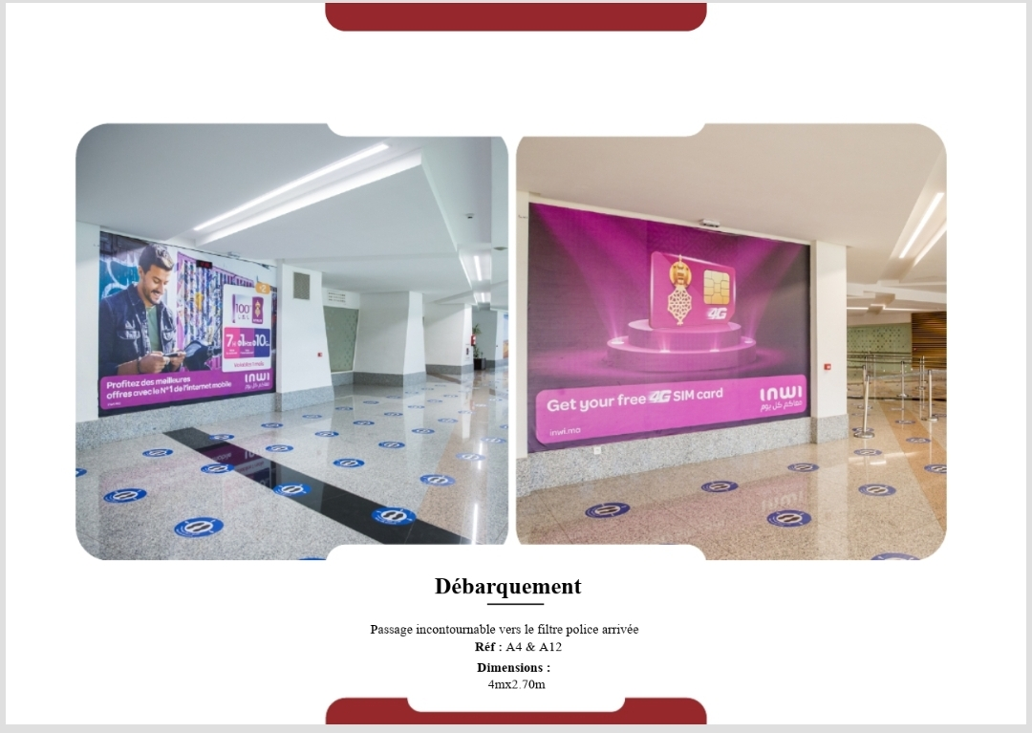

At the key junction leading to immigration police filter, ensuring all arriving passengers pass directly by.  
  
Reference: A4 & A12  
Dimensions: 4m x 2.7m each

## Deboarding – Wall Panels (Set 2)

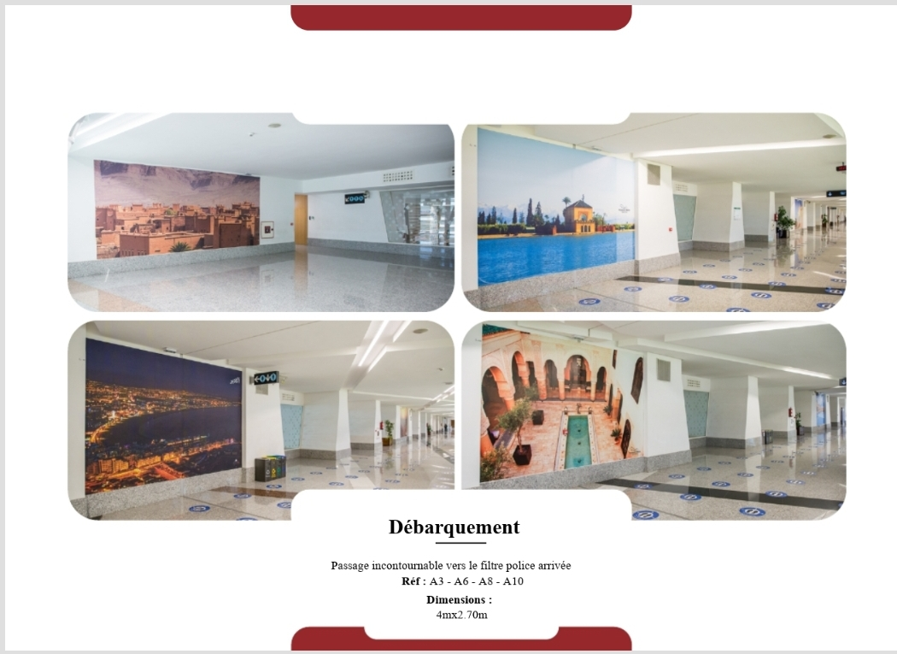

In the corridor funneling passengers to police and baggage zones, with uninterrupted wall space ideal for storytelling.  
  
Reference: A3, A6, A8, A10  
Dimensions: 4m x 2.7m each

## Deboarding – Wall Panels (Set 3)

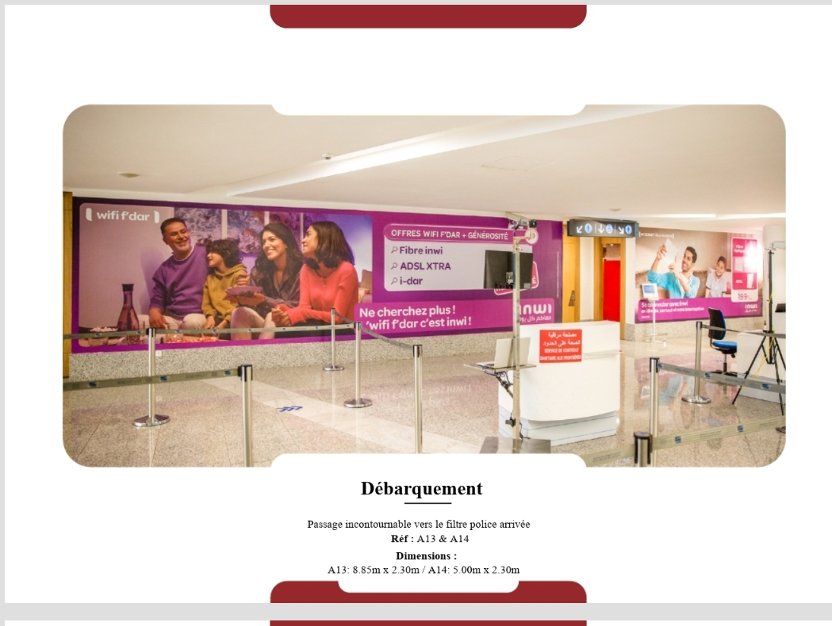

In the corridor funneling passengers to police and baggage zones, with uninterrupted wall space ideal for storytelling.  
  
Reference: A13 & A14  
Dimensions:  
- A13: 8.85m x 2.30m  
- A14: 5.00m x 2.30m

## Deboarding – Escalator Wraps (Set 1)

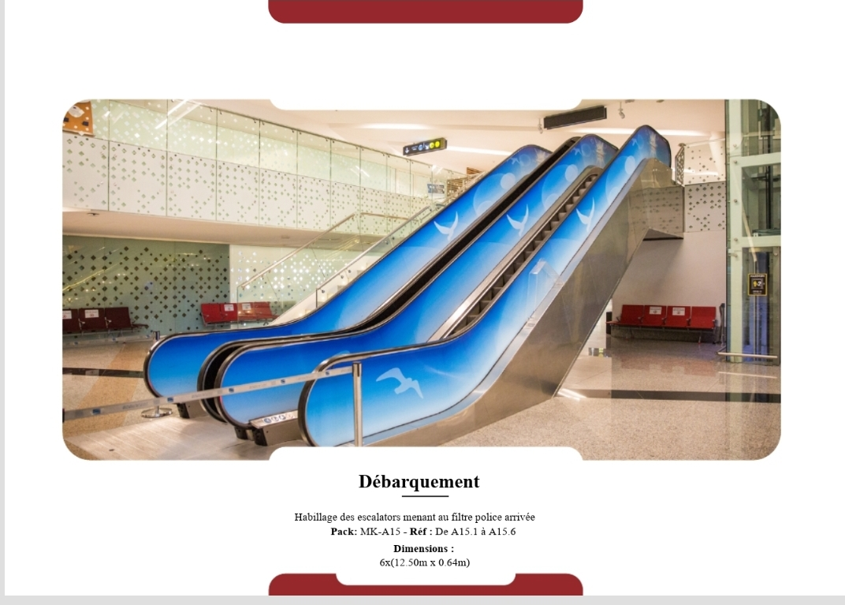

Wraps the entire escalator path where passengers descend or ascend between levels, facing directly toward foot traffic.  
  
Pack: MK-A15  
Reference: A15.1 to A15.6  
Dimensions: 6 x (12.5m x 0.64m)

## Deboarding – Escalator Wraps (Set 2)

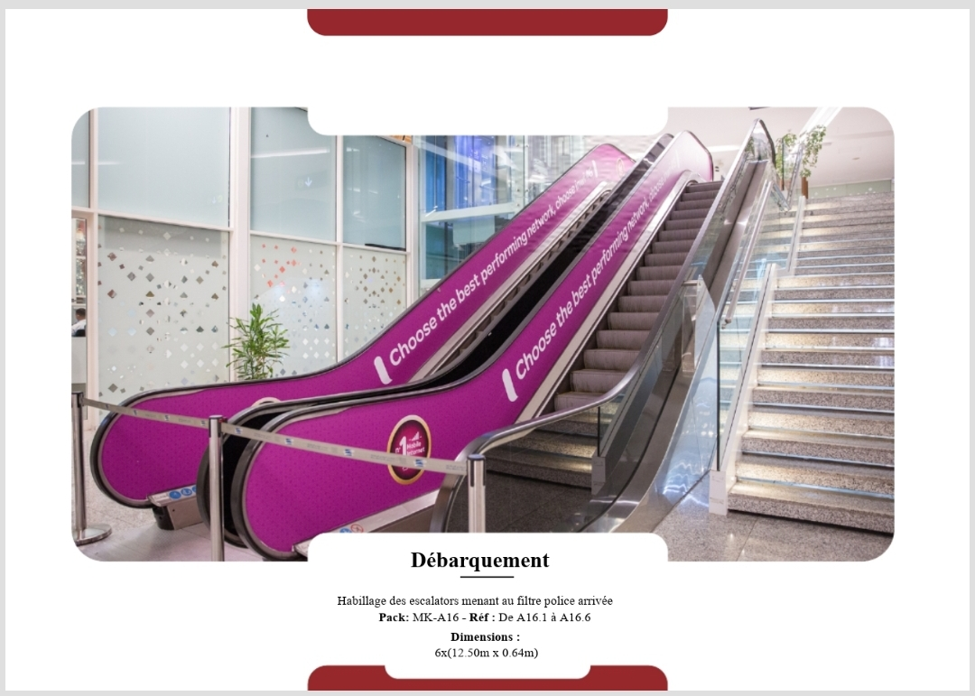

Wraps the entire escalator path where passengers descend or ascend between levels, facing directly toward foot traffic.  
  
Pack: MK-A16  
Reference: A16.1 to A16.6  
Dimensions: 6 x (12.5m x 0.64m)

## Passport Control – Main Entry

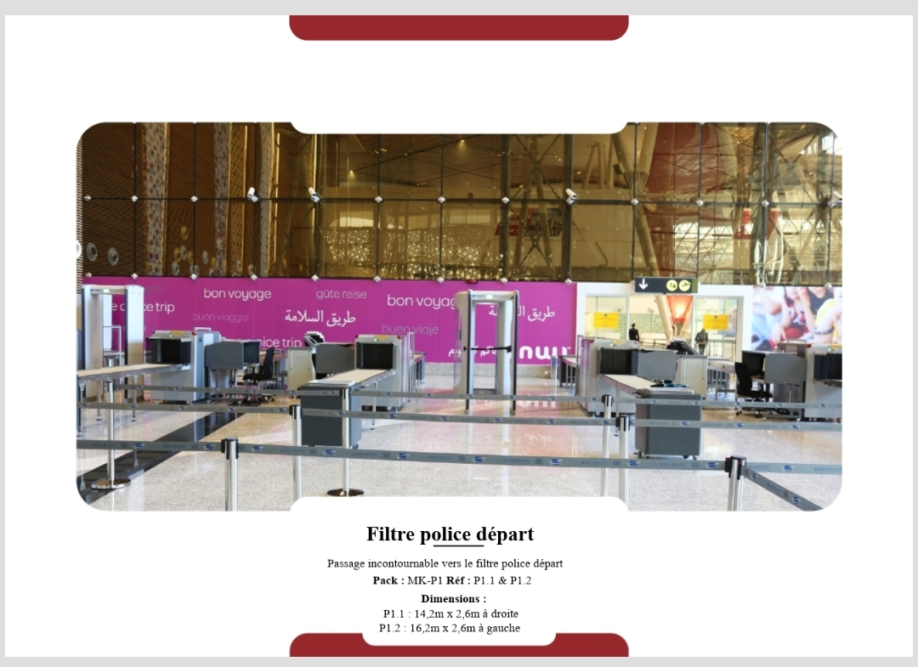

On the main security walls directly behind passport control scanning systems, ensuring maximum exposure during wait times.  
  
Pack: MK-P1  
Reference: P1.1 & P1.2  
Dimensions:  
- Right: 14.2m x 2.6m  
- Left: 16.2m x 2.6m

## Passport Control – Queue Panels (Set 1)

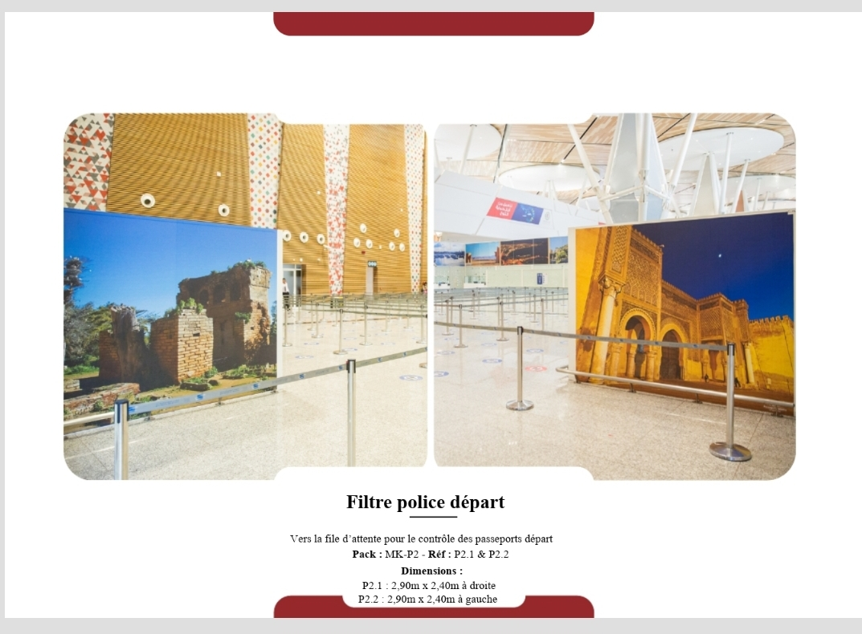

Panels flank the line divider paths for outbound passport checks, seen by every departing traveler.  
  
Pack: MK-P2  
Reference: P2.1 & P2.2  
Dimensions: 2.90m x 2.40m each

## Passport Control – Queue Panels (Set 2)

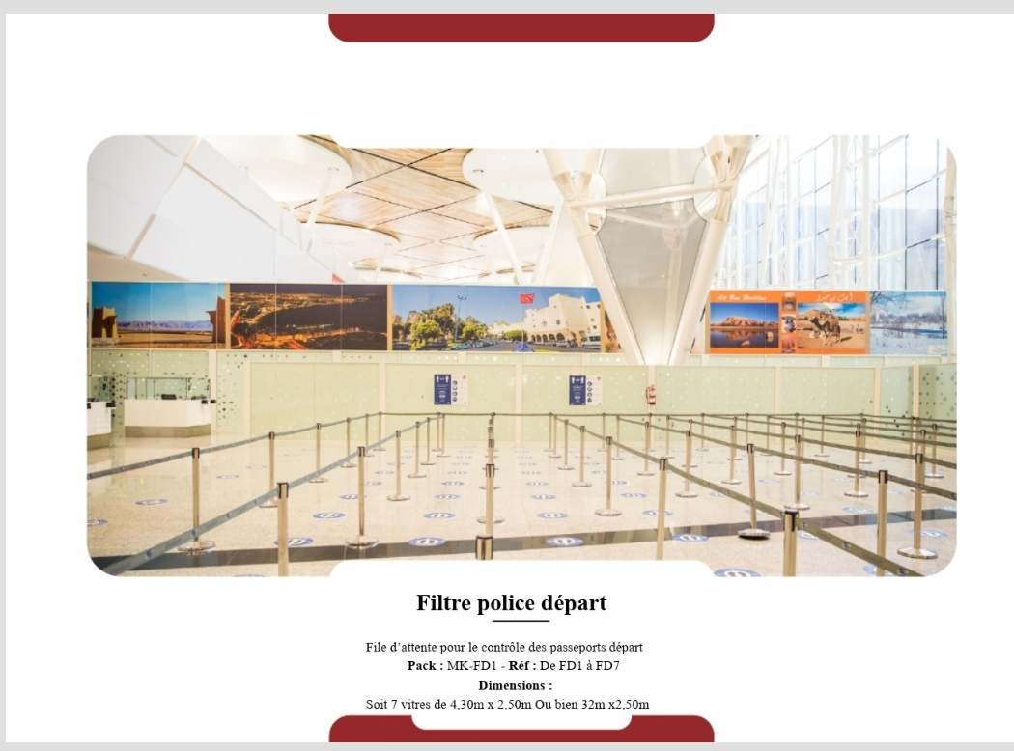

Panels flank the line divider paths for outbound passport checks, seen by every departing traveler.  
  
Pack: MK-FD1  
Reference: FD1 to FD7  
Dimensions: 7 panels of 4.3m x 2.5m or one 32m x 2.5m

## Passport Control – Booth Wall Panels

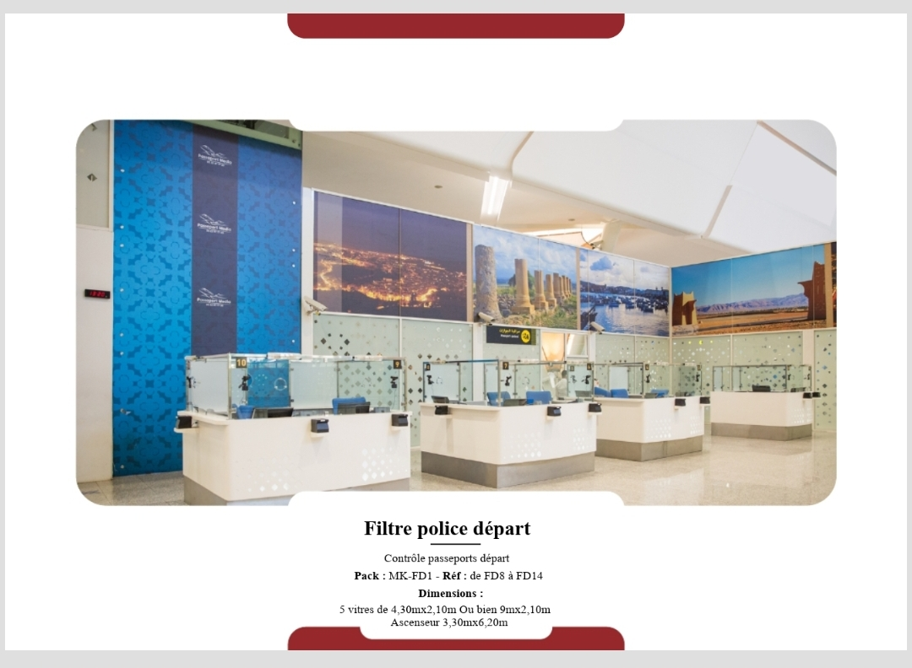

At the exit point of police stamp booths, visible throughout queue and check areas.  
  
Pack: MK-FD1  
Reference: FD8 to FD14  
Dimensions:  
- 5 panels of 4.3m x 2.1m or one 9m x 2.1m  
- Elevator wrap: 3.3m x 6.2m

## Exit Zone – Main Panels

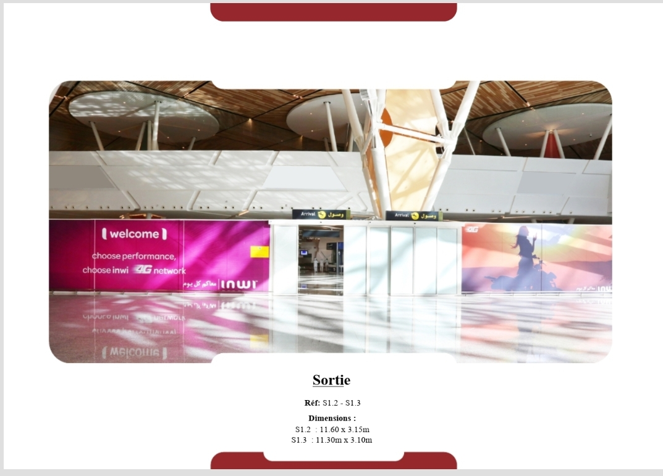

Installed at the exit tunnel just before terminal departure. High visibility during last moments in terminal.  
  
Reference: S1.2 & S1.3  
Dimensions:  
- S1.2: 11.60m x 3.15m  
- S1.3: 11.30m x 3.10m

## Public Hall – Glass Panels

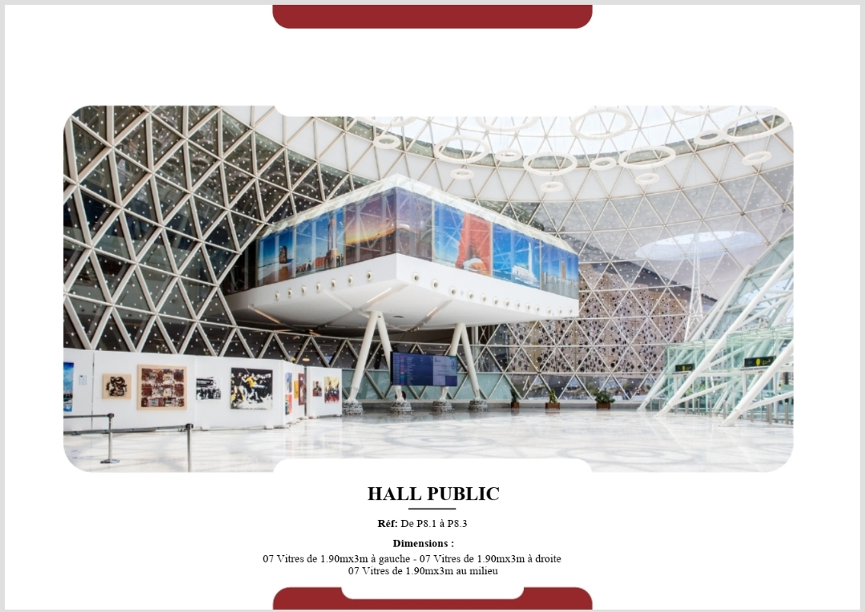

Central atrium of the terminal before security checks, visible to all public guests and greeters.  
  
Reference: P8.1 to P8.3  
Dimensions:  
- 7 panels left: 1.90m x 3m  
- 7 panels right: 1.90m x 3m  
- 7 panels middle: 1.90m x 3m

## Luggage – Opposite Wall Panels

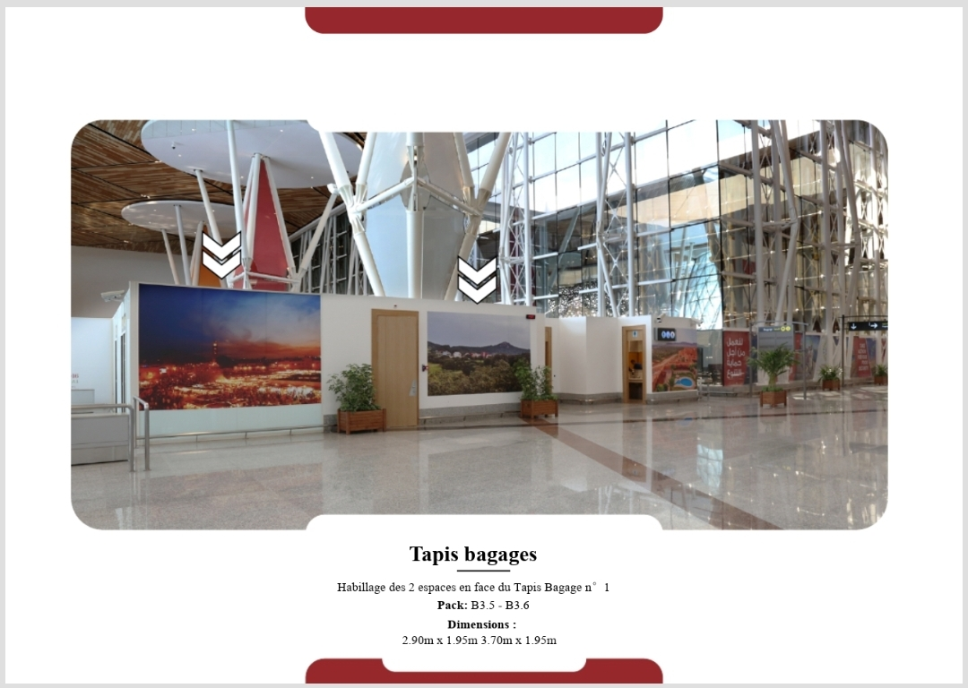

Key location within passenger flow zone.  
  
Pack: B3.5 - B3.6  
Dimensions:  
- 2.90m x 1.95m  
- 3.70m x 1.95m

## Interior Dome Wall Wrap

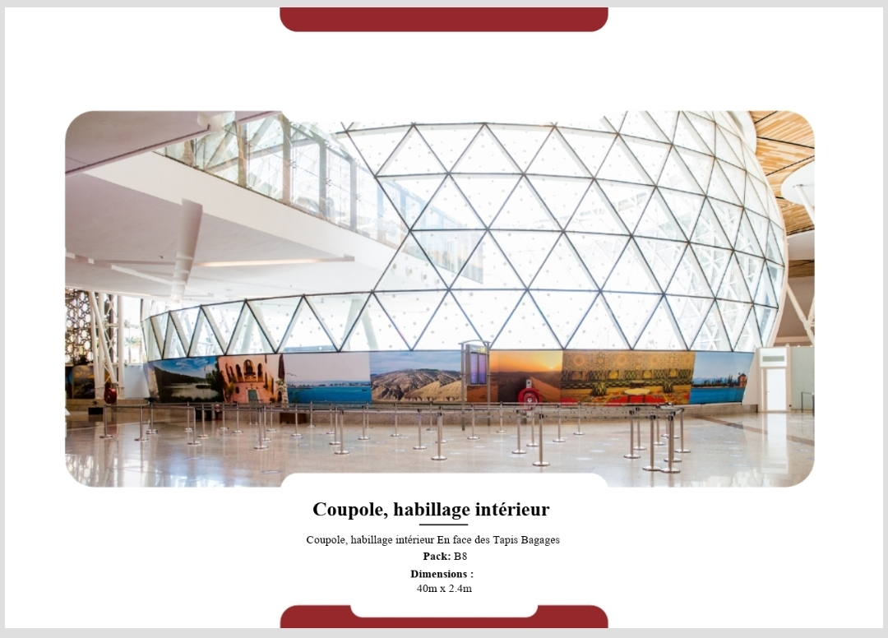

Centrally located opposite luggage belts inside the architectural dome, with panoramic visibility.  
  
Pack: B8  
Location: Facing luggage belts  
Dimensions: 40m x 2.4m